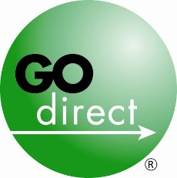
www.GoDirect.org
(800) 333-1795

Go Direct® Community Ambassadors Program Requirements

Financial institutions are encouraged to participate in Go Direct campaign activities throughout the year, however to be recognized as a Go Direct Community Ambassador, your financial institution must complete two of the activities listed below during at least one of three peak campaign months: October (Crime Prevention Month), February (Go Direct Month) and April (Financial Literacy Month)/May (Older Americans Month). Free materials are available and you will have the opportunity to report your activities after each of the peak months.

At least two of the following campaign activities are required:

• Web banners – Post a Go Direct campaign Web banner linking to www.GoDirect.org on your Web site to encourage visitors to sign up online.

• Statement messages and stuffers – Include a Go Direct campaign message in monthly statements or print statement suffers to send to customers or members.

• In-lobby materials – Display free Go Direct campaign posters and teller tents in your branches, offer take-ones to customers or members, and/or attach Go Direct stickers to deposit slips when someone deposits or cashes a federal benefit check, encouraging them to sign up for direct deposit.

• Teller communication/Go Direct campaign communication kit – Communicate to your tellers to remind them to encourage your customers or members who come in to deposit a federal benefit check to switch to direct deposit; or distribute a customized communication kit to branch managers to help communicate the benefits of direct deposit and the Go Direct campaign to tellers and staff.

• Teller/branch incentive – Encourage tellers to promote the Go Direct campaign with an incentive – a small financial reward, free lunch or vacation time – for each customer or member they enroll in direct deposit. Or, stage a competition among branches to see which one can enroll the most people.

Verify that your financial institution fulfilled program requirements at any time by completing the quick, easy online reporting form.

To order materials or to learn more about the Go Direct Community Ambassadors Program, call (952) 346-6055 or visit www.GoDirect.org.

